Guide · Microsoft Copilot Studio · September 2026

Connect Claritalk to Microsoft Copilot
Via the Model Context Protocol (MCP), an agent in Microsoft Copilot Studio can access meetings, summaries, transcripts, files, and tasks from Claritalk. This guide describes how to add the Claritalk MCP server as a tool to an agent.
The connection uses OAuth 2.0 with Dynamic Client Registration: Copilot registers itself as a client with Claritalk, so you don't need to create a Client ID or Client Secret in advance.
Server nameClaritalk Server URLhttps://app.claritalk.com/mcp/claritalk AuthenticationOAuth 2.0, Dynamic (with discovery) Client ID / SecretNot required (DCR) PermissionsRead-only, within your own Claritalk access RequiredCopilot Studio, a Microsoft 365 Copilot license, and a Claritalk account
- 1Create an agent or open an existing oneGo to copilotstudio.microsoft.com, choose Agents in the left sidebar, and click New agent in the top right. You can also open an existing agent.This guide shows the new Copilot Studio experience (toggle "New experience" in the top right).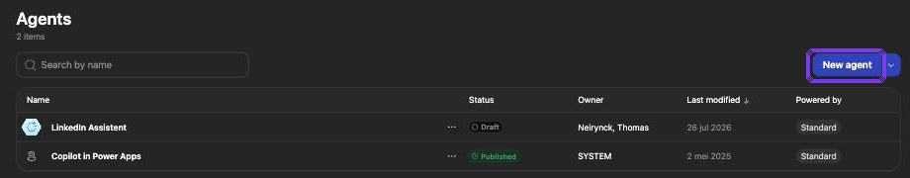Agents overview with the New agent button
- 2Open ToolsGive the agent a name. Click the plus sign next to Tools in the right panel.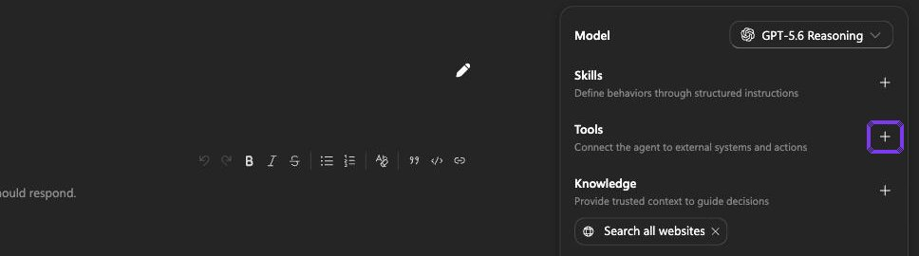Right panel of the agent: Tools
- 3Choose "Model Context Protocol (MCP)"In the Add a tool window, select the tab Model Context Protocol (MCP). The list shows only MCP servers from Microsoft; Claritalk is not among them. Click + Add in the top right.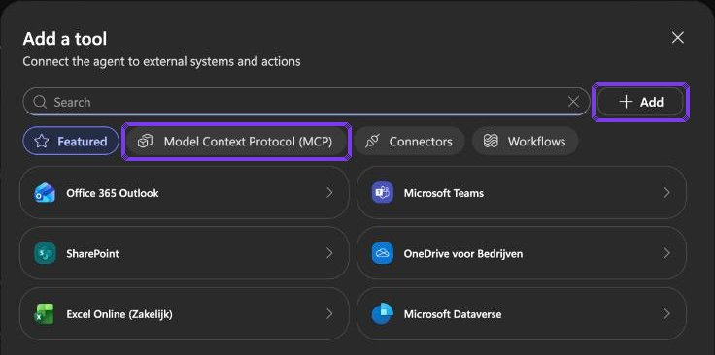Add a tool with the Model Context Protocol (MCP) tab
- 4Add a custom MCP serverIn the menu under + Add, choose Model Context Protocol (MCP).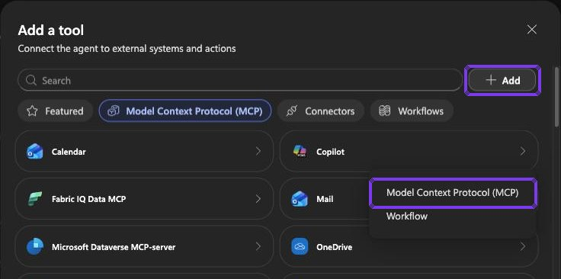Menu under + Add
- 5Enter the server detailsEnter: Server name "Claritalk", a short Server description, and as Server URL https://app.claritalk.com/mcp/claritalk. Choose OAuth 2.0 under Authentication and Dynamic (with discovery) under Configuration type. Click Add.Dynamic (with discovery) allows Copilot to retrieve the OAuth endpoints from Claritalk itself and register via Dynamic Client Registration (DCR). You don't need to enter a Client ID or Client Secret.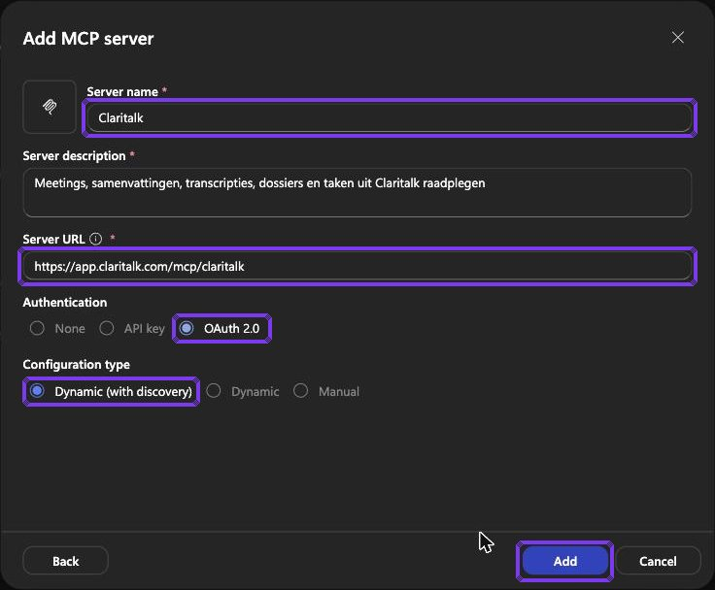Add MCP server: OAuth 2.0 with Dynamic (with discovery)
- 6Create a connectionCopilot displays the Select a connection window. Open the menu next to Not connected and choose Create new connection.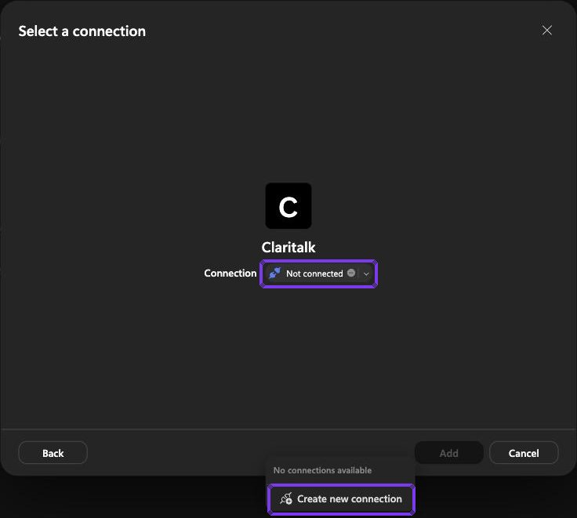Select a connection: Create new connection
- 7Sign in to ClaritalkClick Create. Your browser opens the Claritalk authorization page; verify the account and click Allow access. Back in Copilot Studio, the connection shows as connected; click Add to add the tool to the agent.Through this connection, the agent gets read-only access to conversations, summaries, and transcripts you yourself have access to.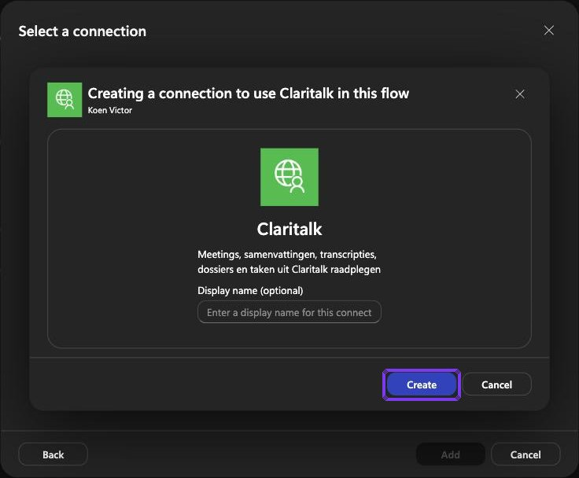Create connection with the Create button
- 8Give the agent display instructionsWithout further agreements, the agent often displays the response from the Claritalk tool as it arrives, including technical fields such as "uuid":"cc1c6569-…". Therefore, specify in the Instructions field (tab Build) how meetings and files should be displayed: with their exact name, clickable, and without raw data.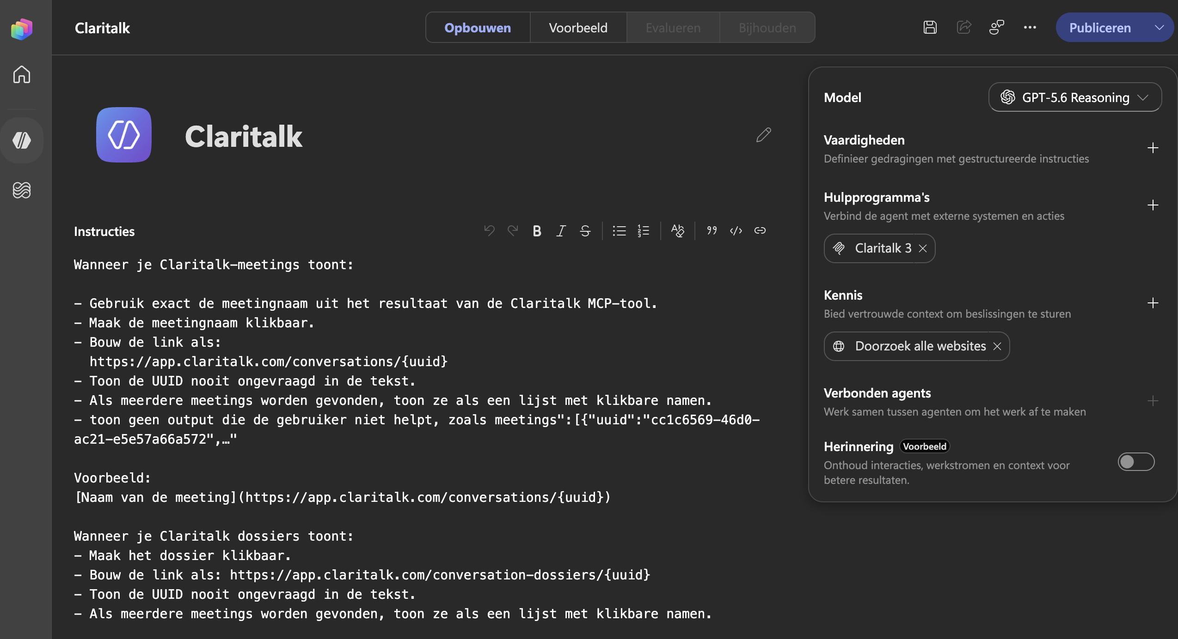The display instructions in the Instructions field of the agentYou can adopt these instructions and expand them further as you see fit:When displaying Claritalk meetings:- Use exactly the meeting name from the result of the Claritalk MCP tool.- Make the meeting name clickable.- Build the link as: https://app.claritalk.com/conversations/{uuid}- Never display the UUID unprompted in the text.- If multiple meetings are found, display them as a list with clickable names.- Do not display output that doesn't help the user, such as "meetings":[{"uuid":"cc1c6569-46d0-ac21-e5e57a66a572", ...Example:[Meeting name](https://app.claritalk.com/conversations/{uuid})When displaying Claritalk files:- Make the file clickable.- Build the link as: https://app.claritalk.com/conversation-dossiers/{uuid}- Never display the UUID unprompted in the text.- If multiple files are found, display them as a list with clickable names.Save the agent after adjusting the instructions. In Preview, you can immediately see whether the meeting names appear as clickable links.
- 9Test and publishSave the agent, test a question in Preview such as "What meetings did I have this week?" and then click Publish in the top right to make the agent available in Microsoft 365 Copilot.

What the agent can do afterwards
- Retrieve meeting information and meeting summaries.
- Search for files and tasks.
- Search transcripts for appointments or topics.
- Create reports based on a period or team.

Troubleshooting
- No sign-in screen: verify that the server is reachable and that the user has access to Claritalk.
- Registration error (BadRequest): the Claritalk server does not accept the DCR request from Copilot; contact Claritalk.
- Tools not loading: check the server URL and whether the user has signed in successfully; disconnect and reconnect.
Screenshots taken in Microsoft Copilot Studio (new experience) on September 11, 2026. The interface may have changed slightly in the meantime; the order of the steps remains the same.

