Claritalk · Guide

Add Claritalkto ChatGPT
Connect Claritalk via MCP and ask ChatGPT questions about your conversations and files. Sign in with your Claritalk account via OAuth.
You add Claritalk as a custom MCP server in ChatGPT's plugin catalog. A separate developer mode is no longer required.
English ChatGPT interface · Screenshots from October 8, 2026

1. Open the plugins
Click the Plugins icon in the left sidebar of ChatGPT, or go directly to chatgpt.com/plugins. You arrive at the Customize → Plugins page with the catalog and your installed plugins.
You can also access it via your profile menu (bottom left) → Settings → Integrations → Plugins → Browse catalog.
A separate developer mode no longer needs to be enabled. The availability of custom MCP servers depends on your subscription and your organization's settings. At the bottom of the form in step 2, you'll find the link Read the guide to OpenAI's documentation.
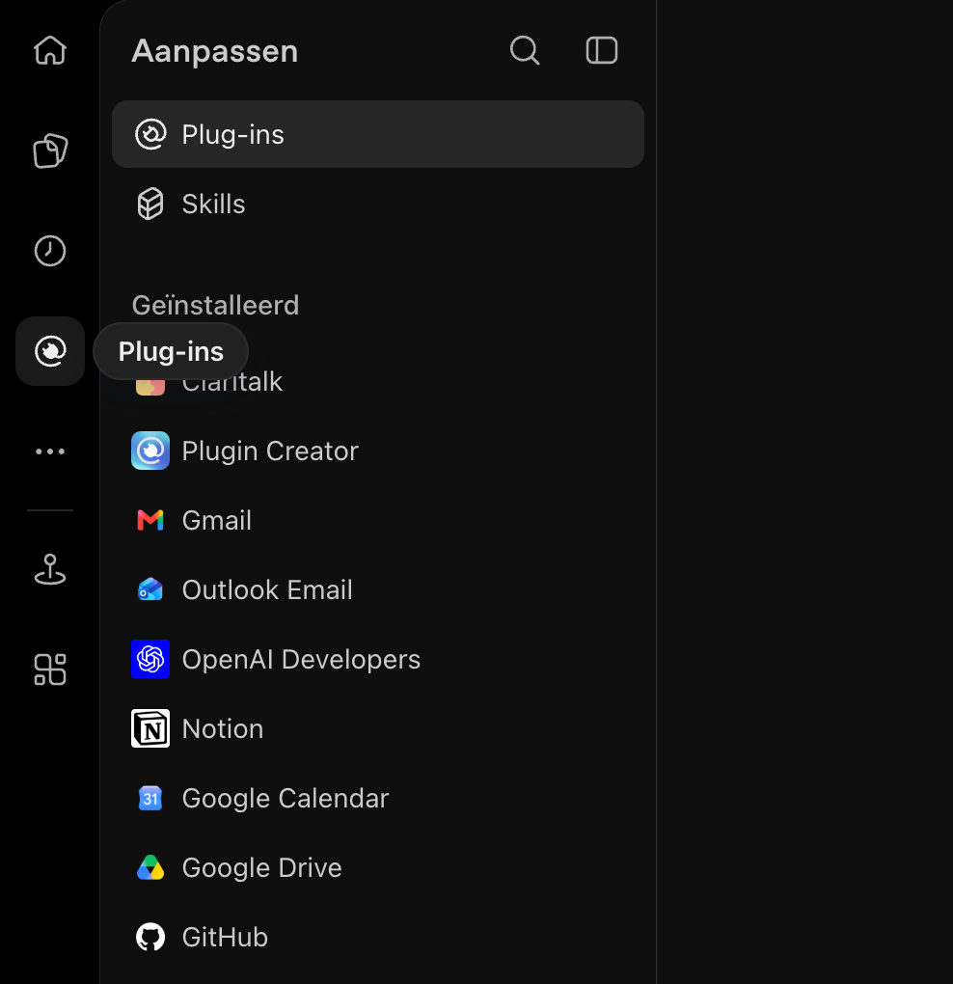
The Plugins icon in the left sidebar opens the Customize page.

2. Add a custom MCP server
Click Add in the top right and select Create custom MCP server. The other options (Create a plugin and Upload plugin archive) are not needed for Claritalk.
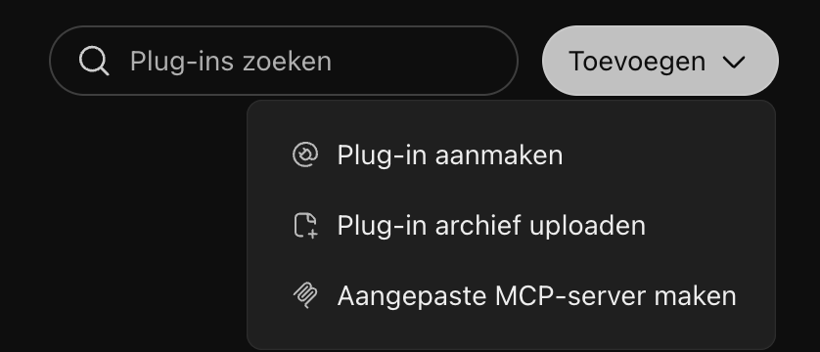
In the Add menu, choose Create custom MCP server.

3. Enter the Claritalk details
Use the following settings. Adding an icon is optional. Leave Connection set to Server URL (not Tunnel).
Field | Value
Name | Claritalk
Description (optional) | Search and review your Claritalk conversations and files.
Connection | Server URL
Server URL | https://app.claritalk.com/mcp/claritalk
Authentication | OAuth
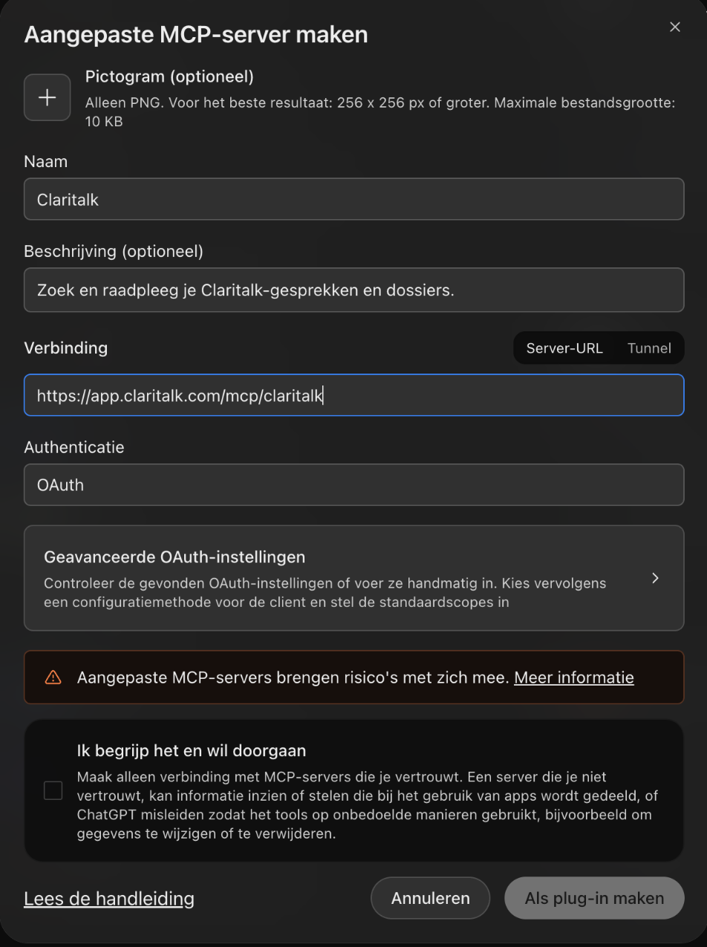
Example of the completed form. The permission checkbox is not yet checked.

4. Check the OAuth settings
Once you've entered the server URL, ChatGPT automatically recognizes Claritalk's OAuth configuration. Click Advanced OAuth settings to view them; the form expands to the right. You'll see:
- Registration method: Dynamic Client Registration (DCR).
- Default scopes: mcp:use (checked).
- OAuth endpoints: automatically detected (https://app.claritalk.com/oauth/authorize and .../oauth/token).
Leave these settings as they are. With DCR, you don't need to manually enter a Client ID or Client Secret. The message that CIMD is not available does not prevent the use of DCR.
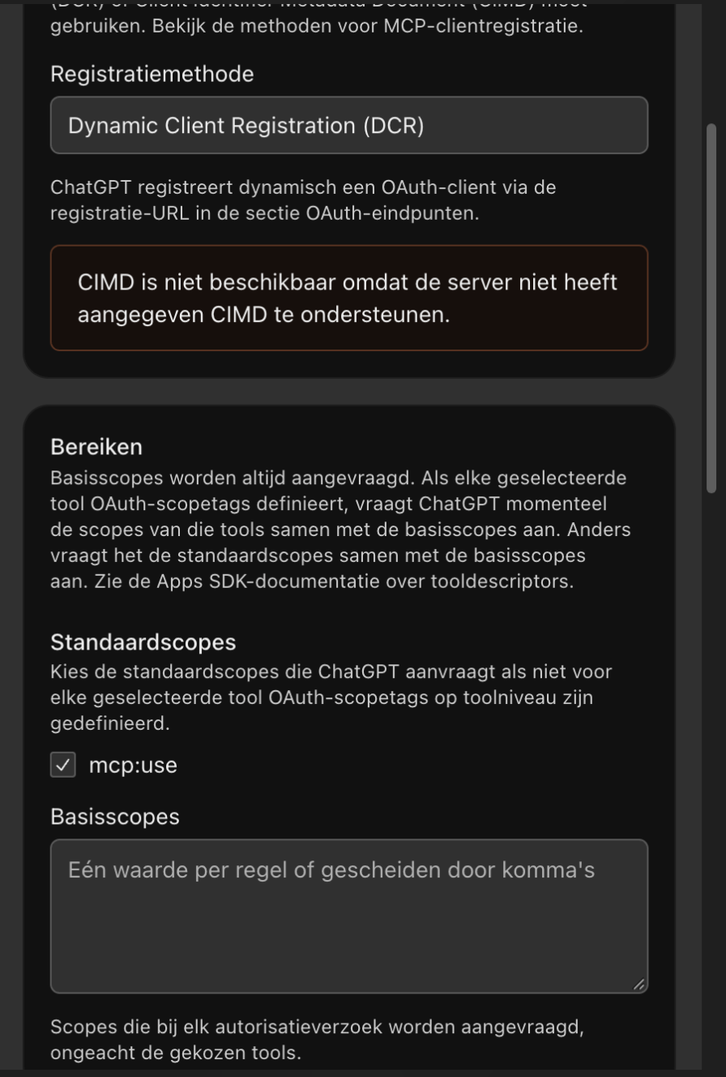
Automatically recognized settings for Claritalk: DCR and mcp:use.

5. Establish the connection and sign in
- Read the message that custom MCP servers carry risks.
- Check I understand and want to continue and click Create as plugin. The button becomes active only after checking.
- ChatGPT creates the plugin and displays the Connect Claritalk window with information about permissions and shared data. Click Continue to Claritalk.
- You're taken to the Claritalk sign-in page. Sign in if necessary. If you're already signed in, the Connect ChatGPT screen appears immediately.
- Check the account under Signed in as. ChatGPT only requests read access to conversations, summaries, and transcripts that you have access to. The connection cannot create, modify, or delete anything in Claritalk.
- Click Allow access to grant permission, or Cancel to cancel.
- You're automatically returned to ChatGPT. A brief message Primary is now connected appears at the top.
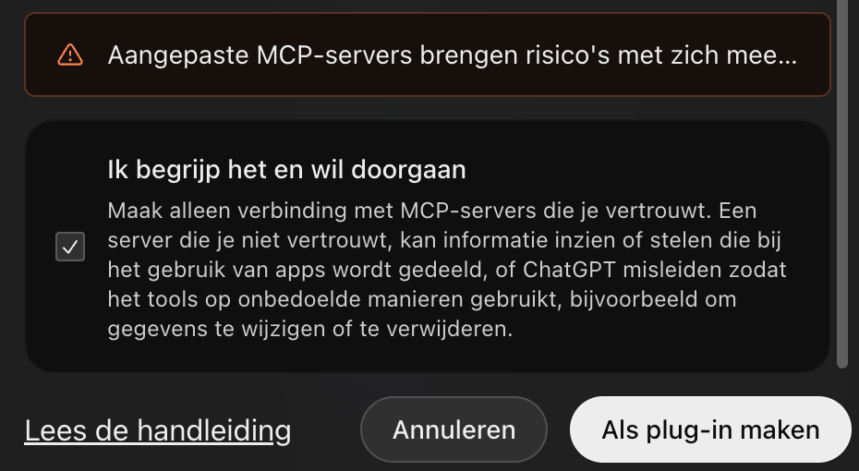
Check the checkbox and click Create as plugin.
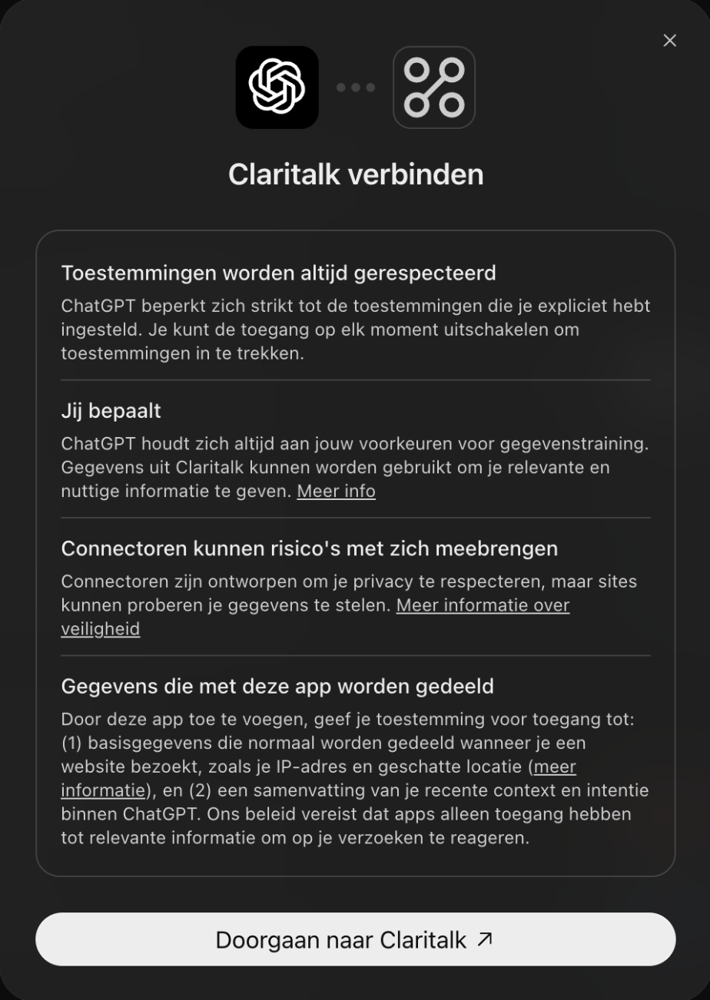
ChatGPT first shows an overview of permissions. Click Continue to Claritalk.
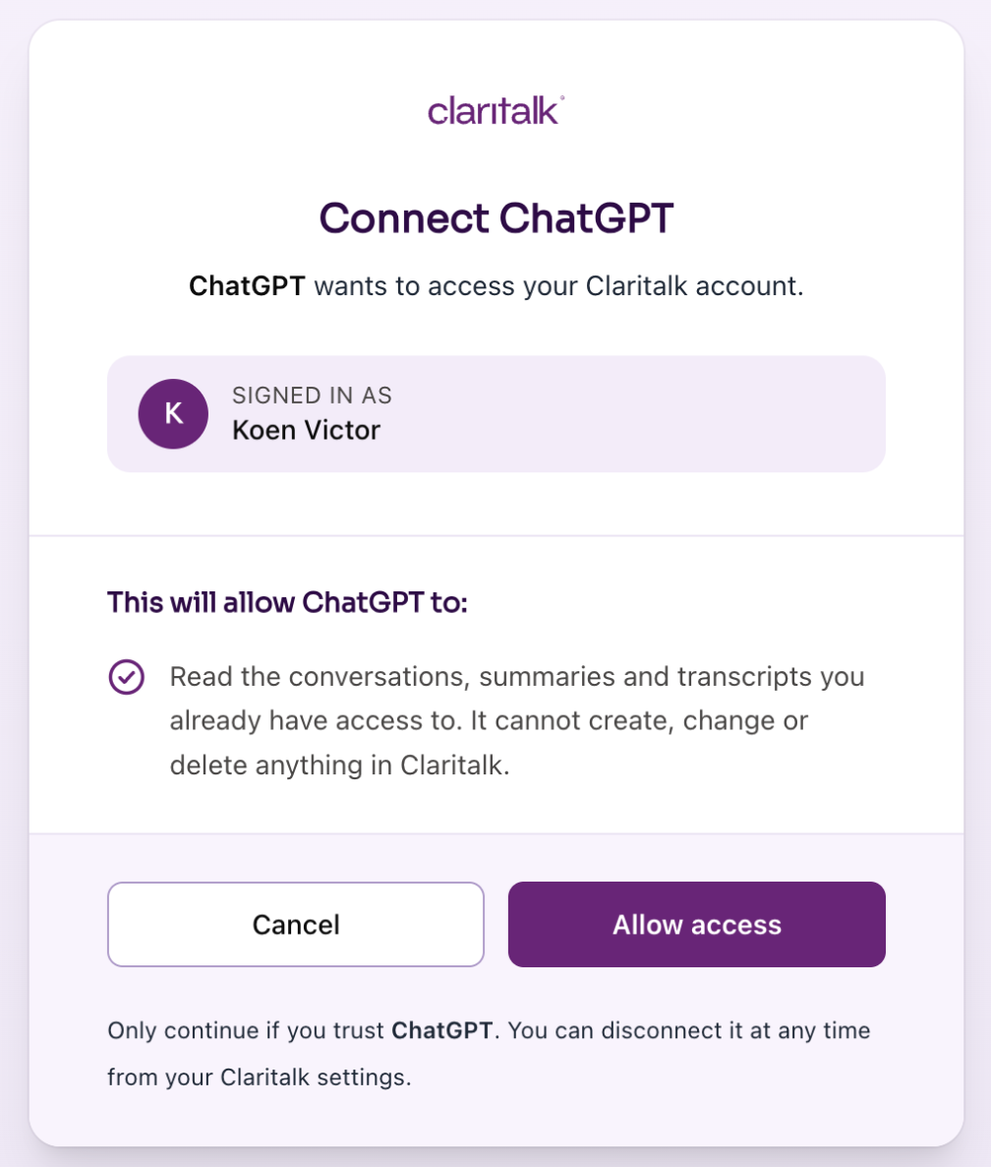
Check the signed-in account and click Allow access to grant permission.
After granting permission, you'll see the Claritalk plugin page in ChatGPT. Under Connected accounts, your Claritalk account is listed with the label Primary. Under Authorization, you can set when ChatGPT asks for permission before using the plugin; the default value is Allow low-risk.
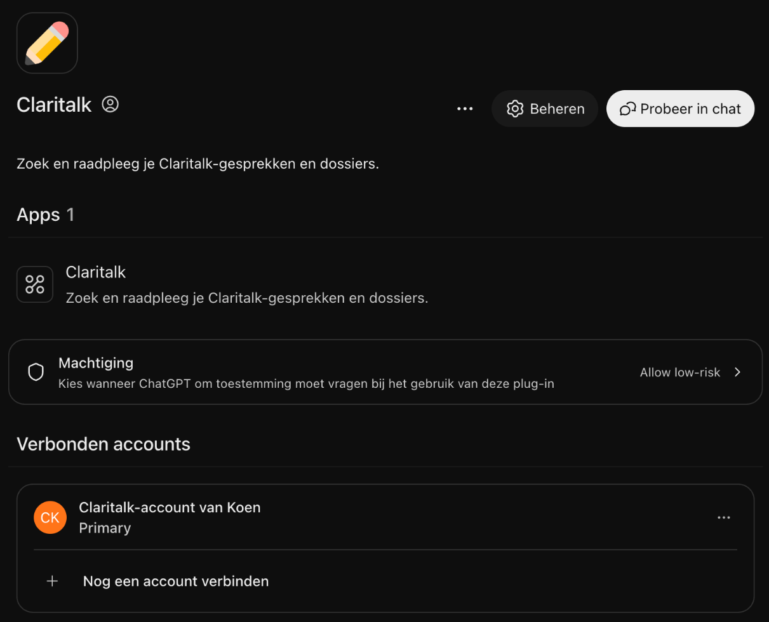
ChatGPT displays the Claritalk plugin with the connected account after confirming access.

6. Use Claritalk in a conversation
On the plugin page, click Try in chat. ChatGPT opens a new chat with @Claritalk already in the input field. Type your question after the mention.
In an existing or new chat, you can also call Claritalk yourself: type @Claritalk in the input field, or click Plugins below the input field and check Claritalk.
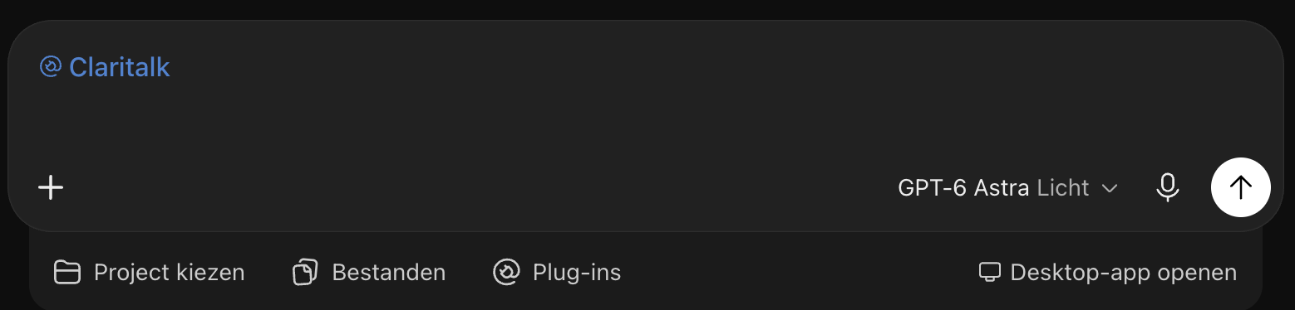
After Try in chat, @Claritalk is already ready in the input field.
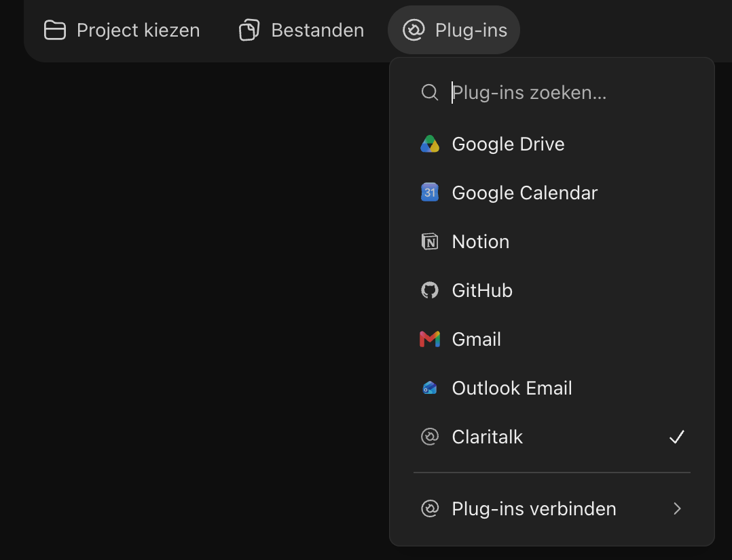
Use the Plugins button below the input field to select Claritalk for the conversation.
Try for example:
Use Claritalk to show my five most recent conversations.
Search Claritalk for conversations about customer follow-up and summarize the key agreements.

Not working?
- No Add button or no Create custom MCP server option: ask your workspace administrator whether custom MCP connections are allowed for your account.
- Message "An app with this name already exists": there's already a plugin named Claritalk under Installed. Open that plugin and click Connect to link the account, or remove them first via ⋯ → Remove plugin and create them again.
- Connection failed: check the complete server URL (https://app.claritalk.com/mcp/claritalk) and the OAuth selection.
- Account not connected: open the plugin via Plugins → Installed → Claritalk and click Connect on the app to restart the OAuth sign-in.
- Claritalk not being used: type @Claritalk in your message or select the plugin via the Plugins button below the input field, and mention Claritalk explicitly in your question.

