Integration

Connection with FID-Manager
With the FID-Manager connection, the PDF of each meeting is automatically added to the correct contact. You only need to complete these steps once.

Step 1 — In FID-Manager
- Open the document parametersGo to Documents / Document parameters.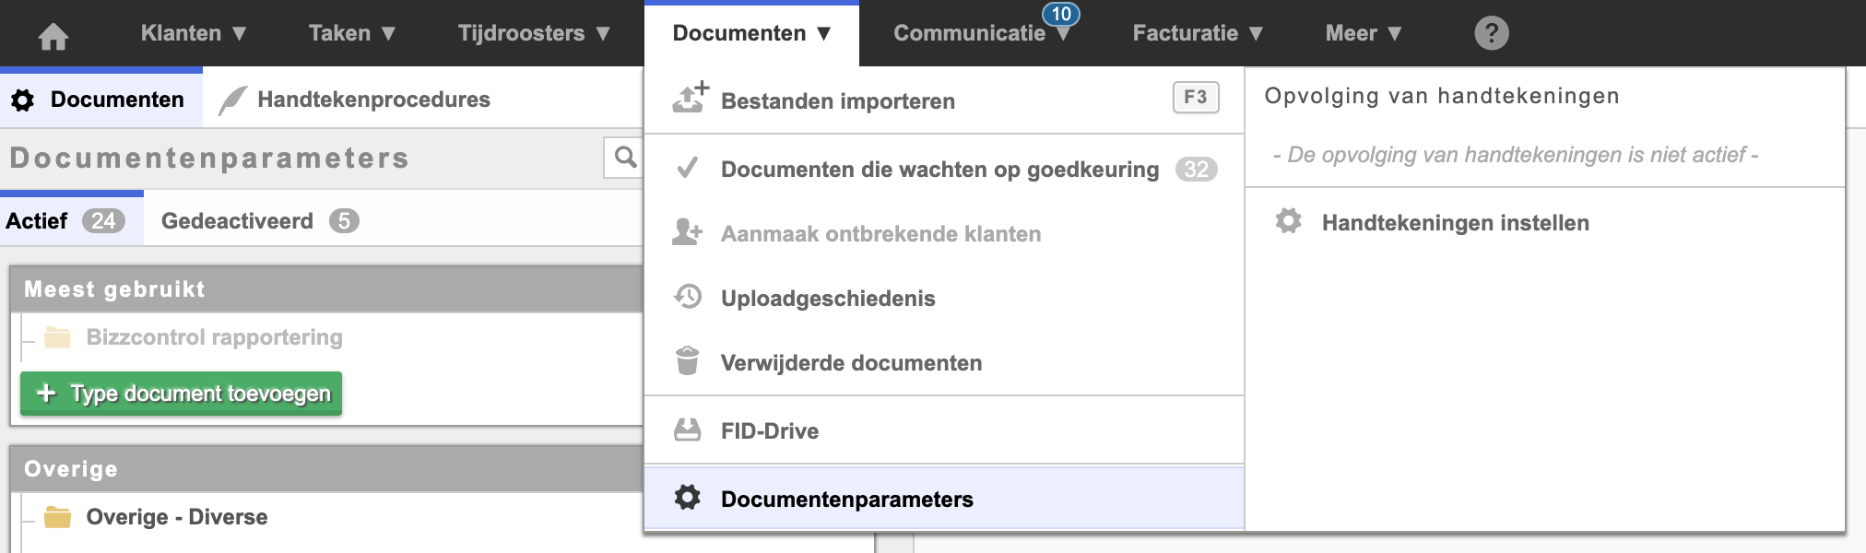Documents › Document parameters in FID-Manager
- Add a new document typeClick on Add document type.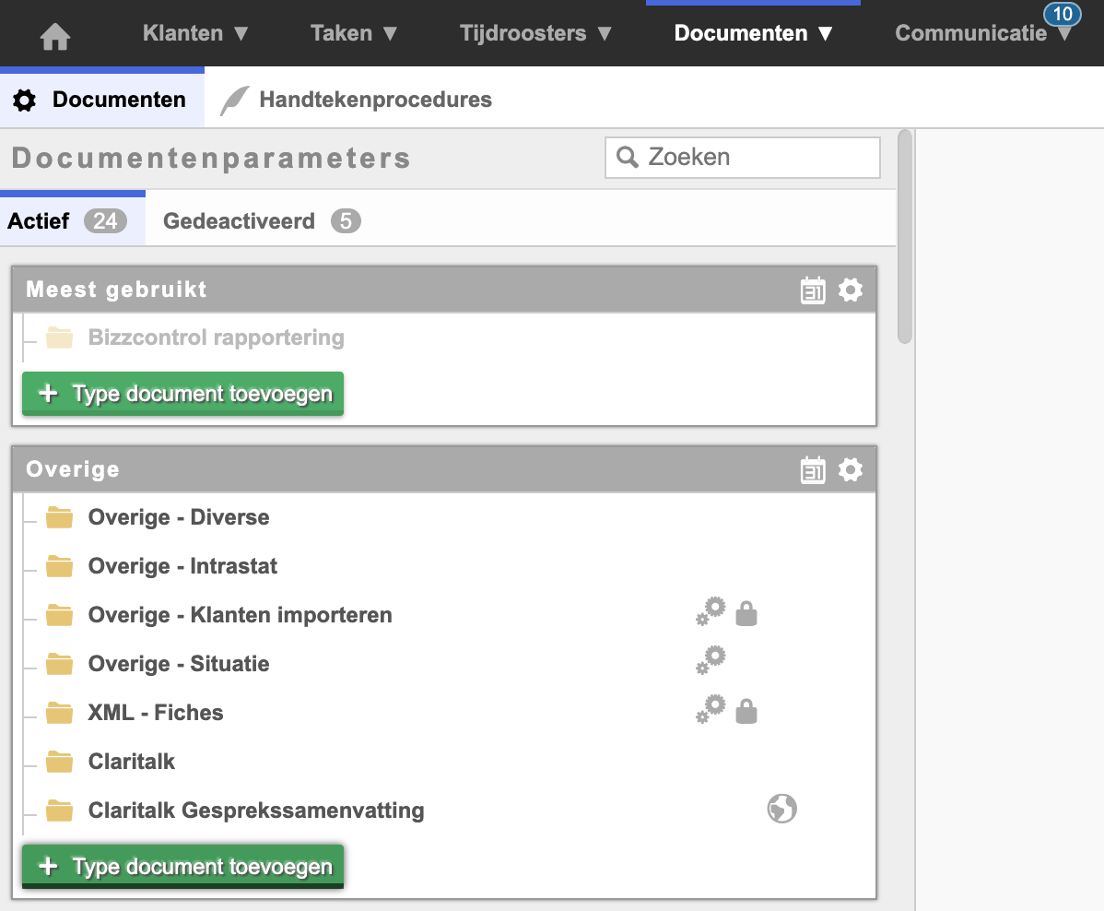Add document typeEnter: Claritalk Summary.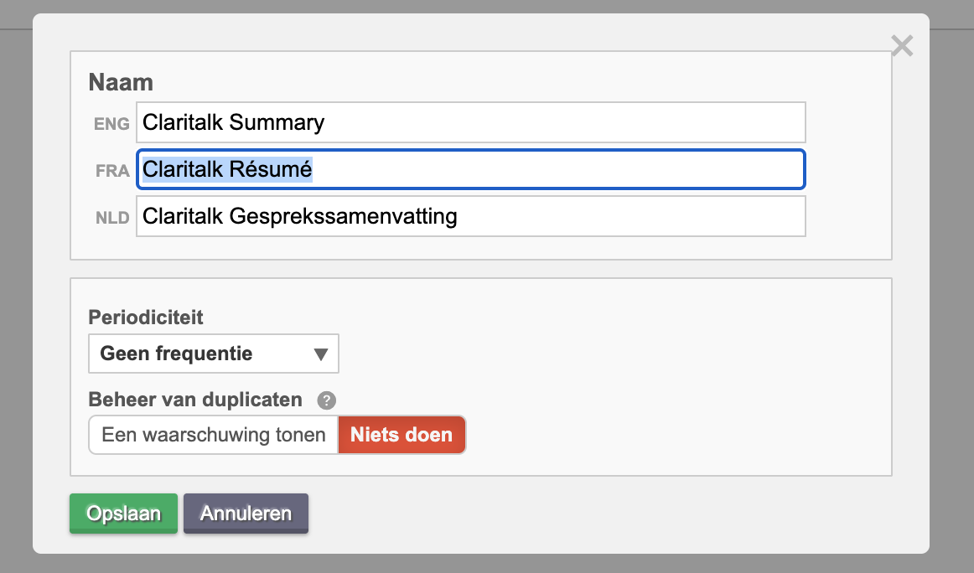Enter document type “Claritalk Summary”
- Make the document type available to the APIClick on “Parameters for external software access (API)” and then click on Claritalk.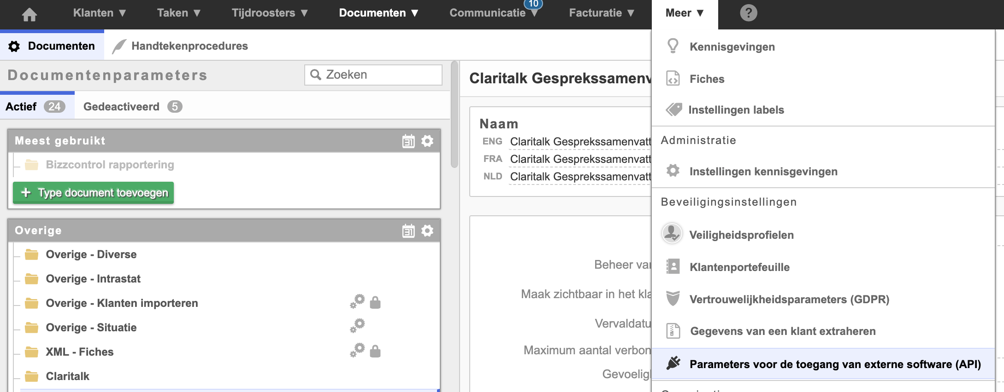Activate API access for ClaritalkYou will receive an email with the access codes.
- Enter the partner codeClick on “Document authorizations” / Other and enter CLARI for Claritalk.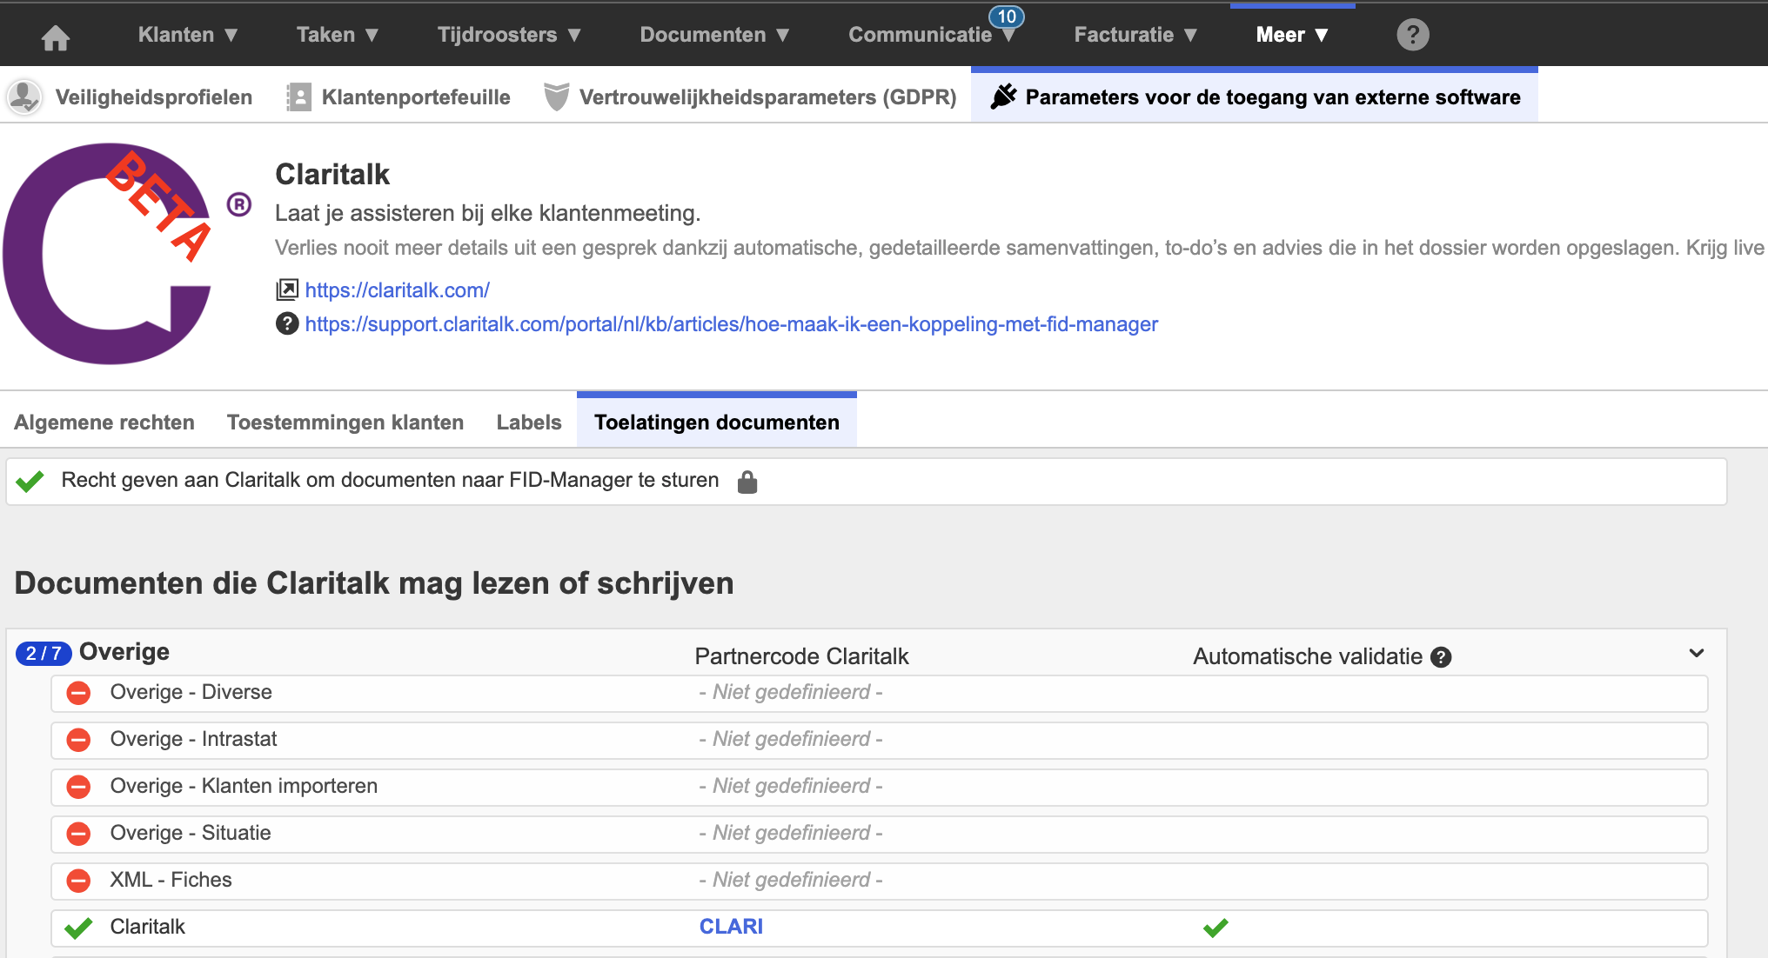Enter partner code CLARI in Document authorizations
Attention
The password that FID-Manager sends is one password per company and must be used by everyone. Share it with other users who need FID-Manager access. With each new request, FID deletes the previous password.

Step 2 — In Claritalk
- Open the marketplaceGo to app.claritalk.com › profile › marketplace and click on FID-Manager.
- Enter the access codesUse the codes from the email from FID-Manager.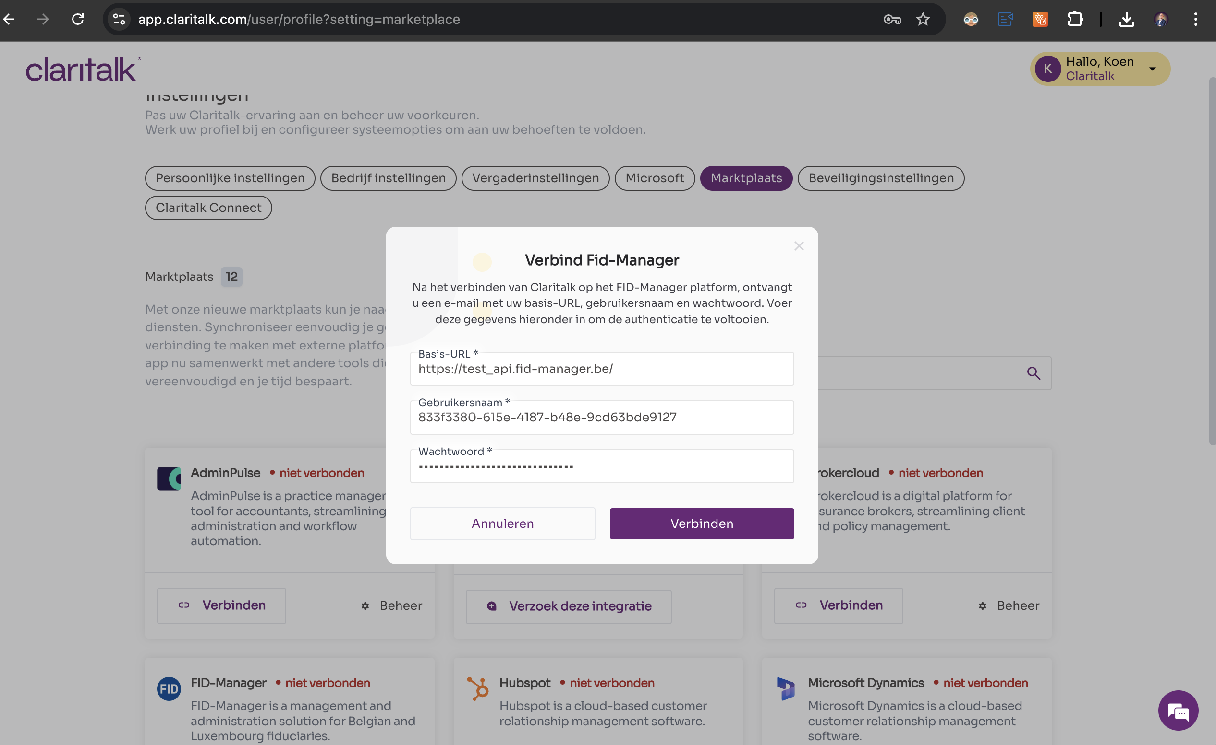Enter access codes in Claritalk
- Enter the partner codeClick on Configuration and enter the partner code CLARI.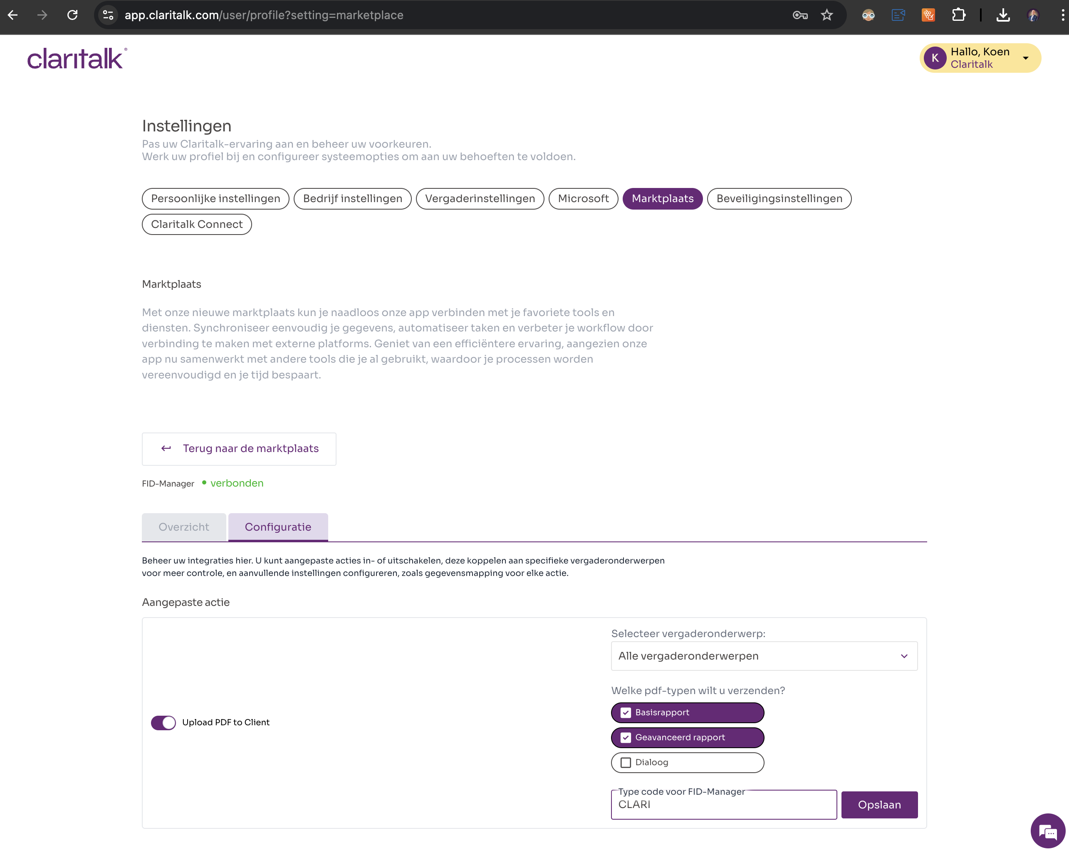Enter partner code CLARI in the configuration

The result
Done
When starting a meeting, you can now select the contact you are meeting with. After the meeting, the PDF of the meeting is automatically added to that contact. Good luck!
Found an error or need an addition? Send a message to support@claritalk.com and we will help you further.

