Rollout

Distribute Claritalk Connect via Microsoft Intune
Here's how to push Claritalk Connect as a line-of-business app to the right user groups in your organization.

Adding the app in Intune
- Download the latest msi versionGet the latest .msi of Claritalk Connect from the public repo.
- Create a new appGo to Intune/Endpoint and then to Apps.Apps › New › Line-of-business app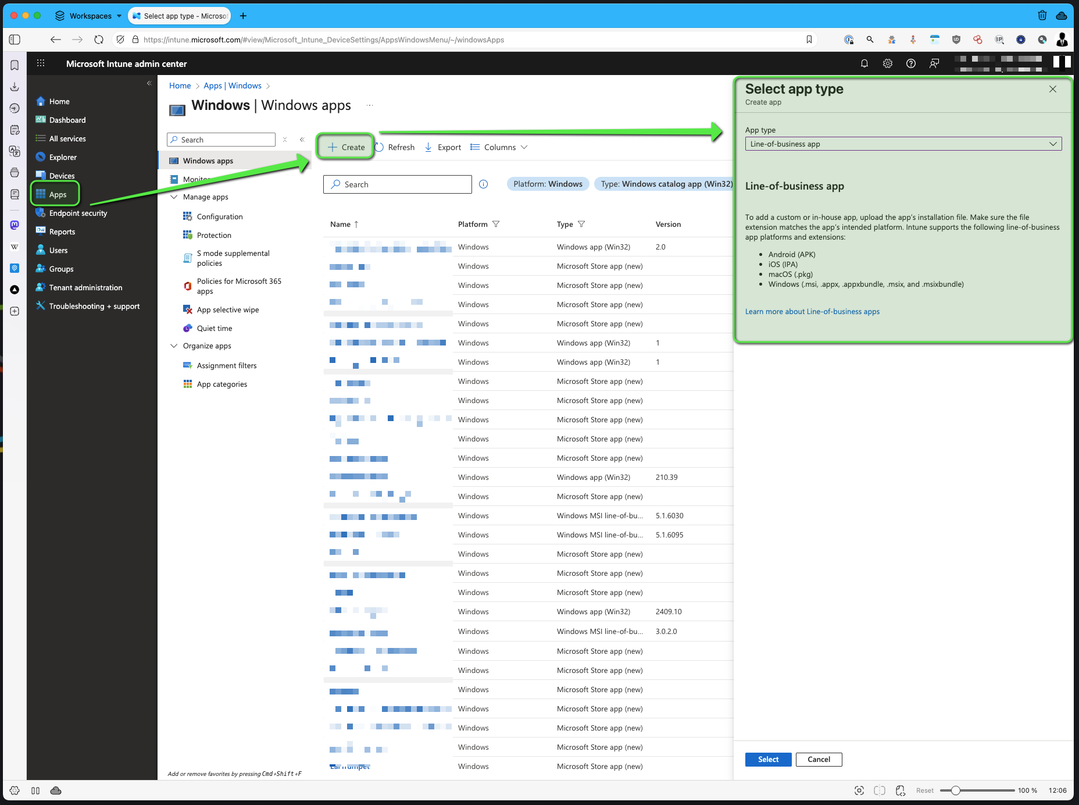Creating a new line-of-business app
- Upload the app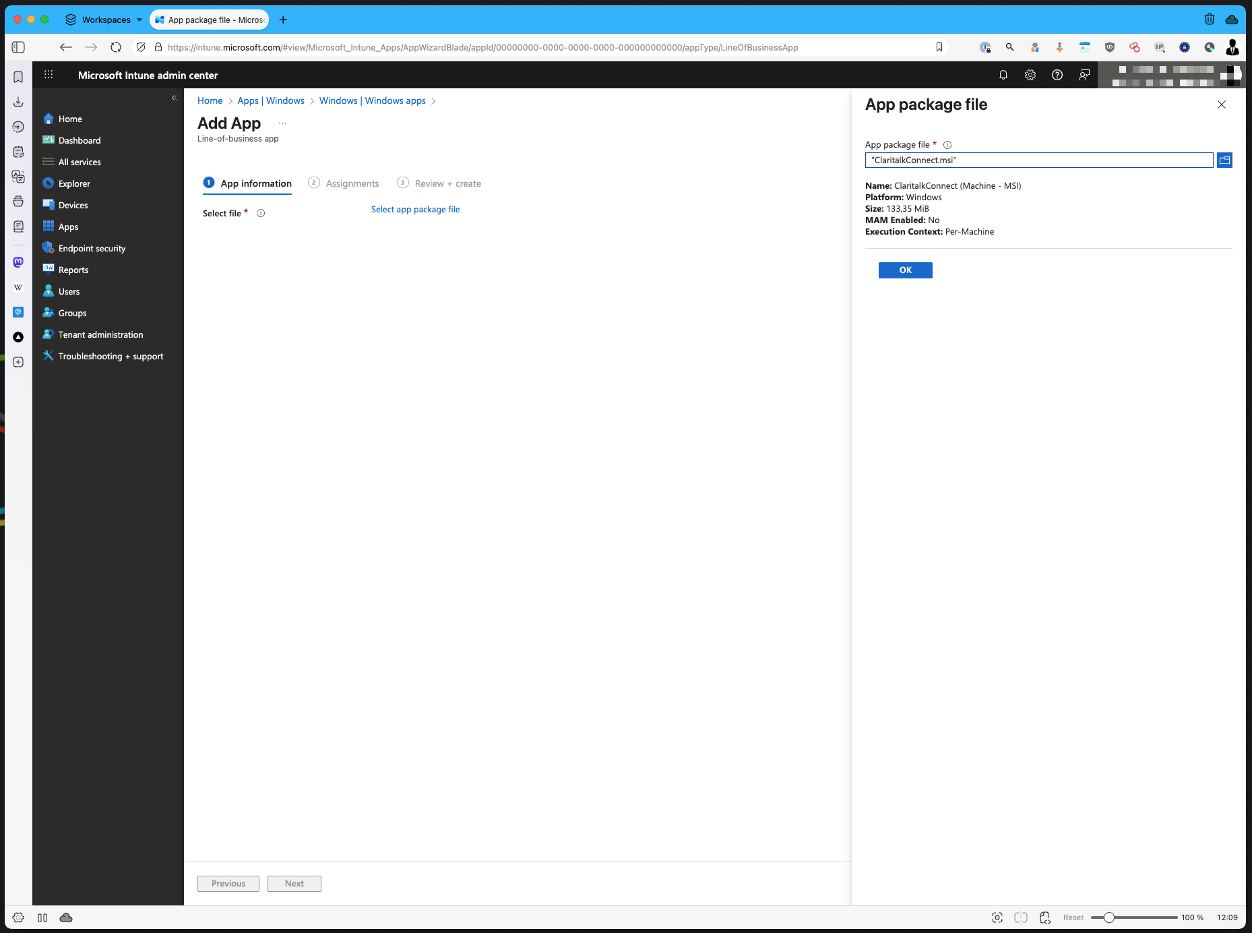Uploading the msi
- Fill in the informationUpload the logo and add the category.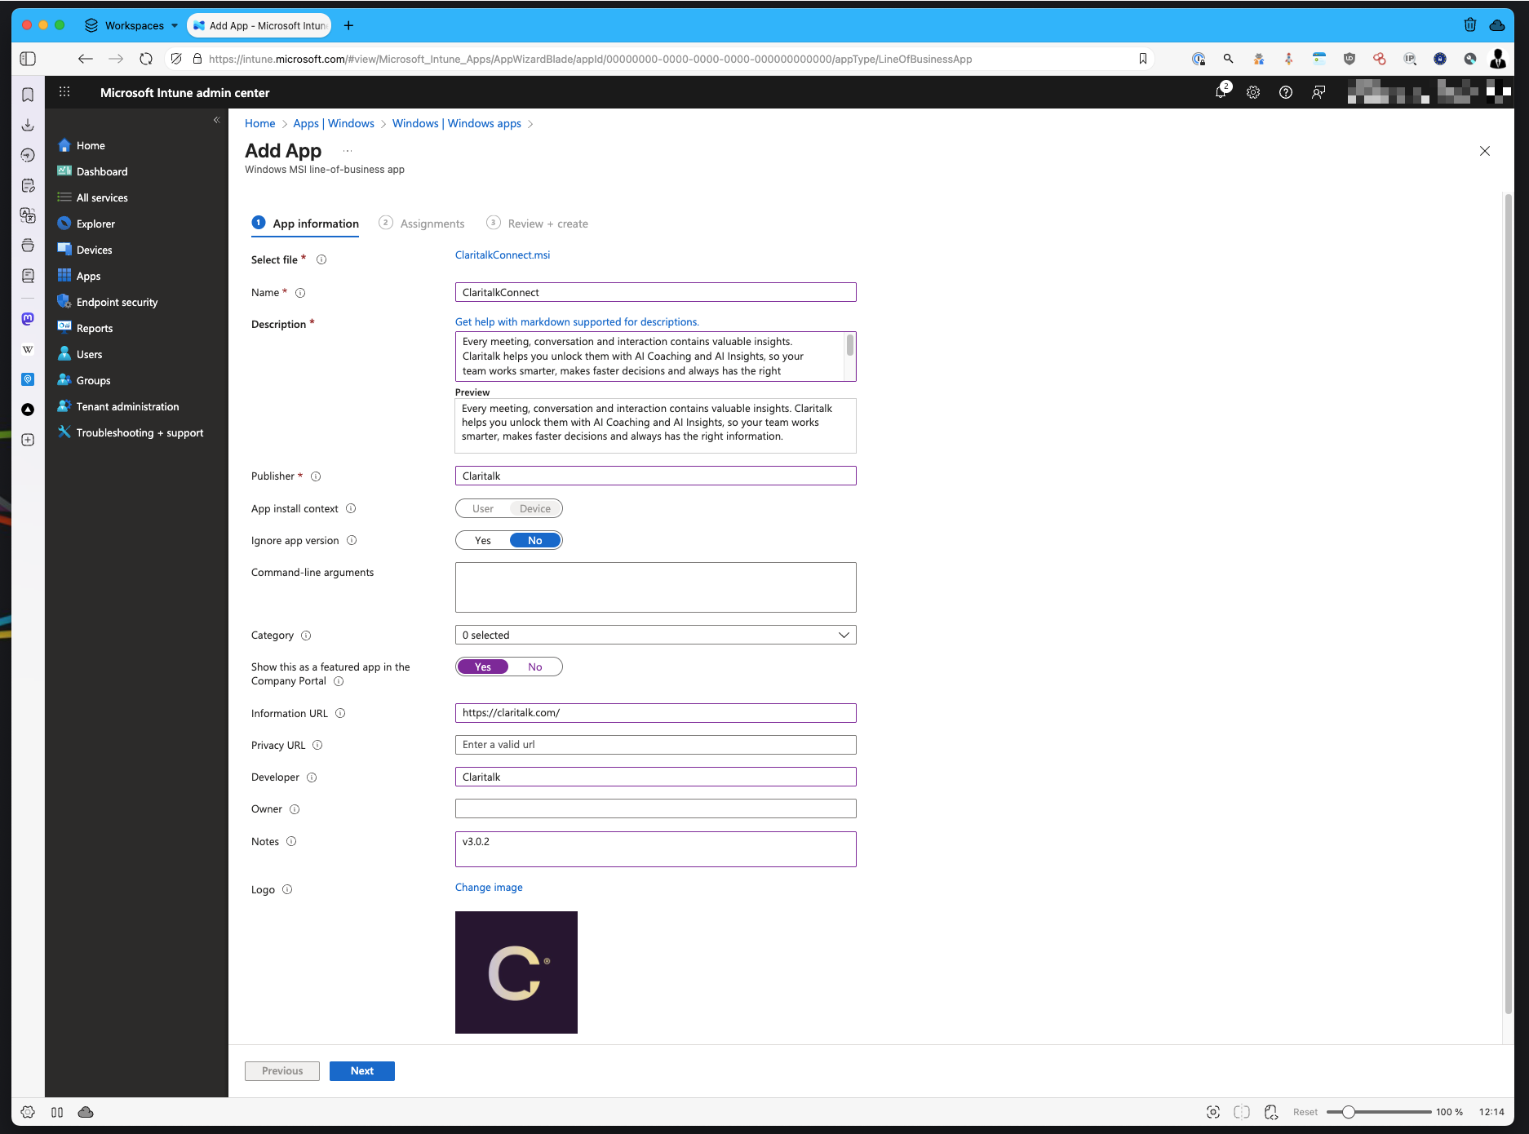Entering app information and category
- Select the groupsSelect the groups to whom you want to push the app.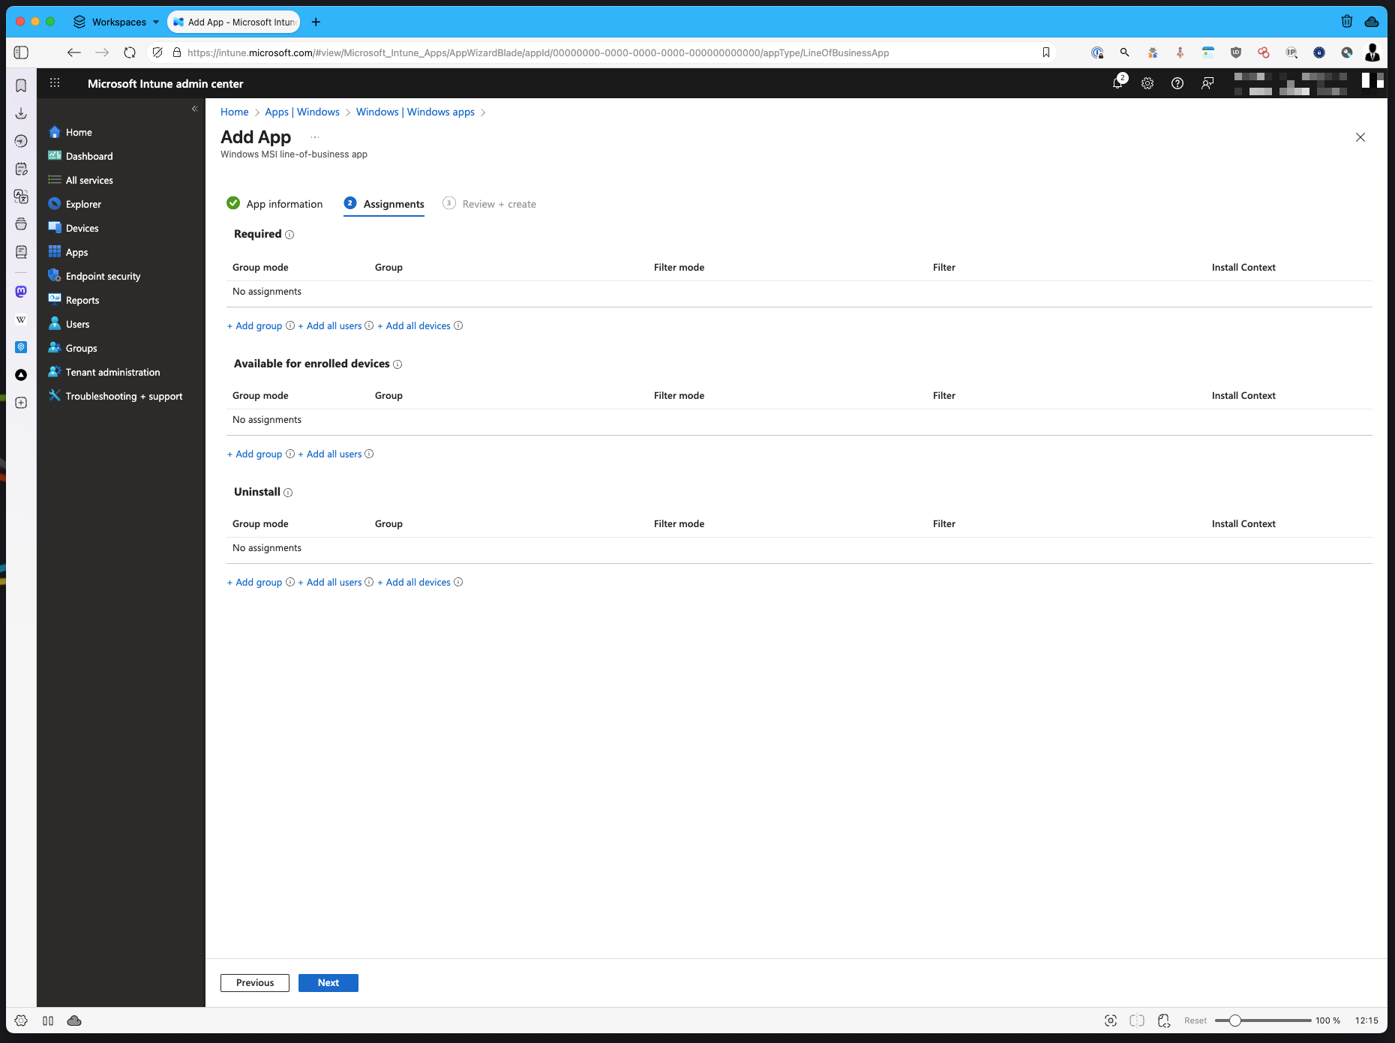Selecting target groups
- Et voilà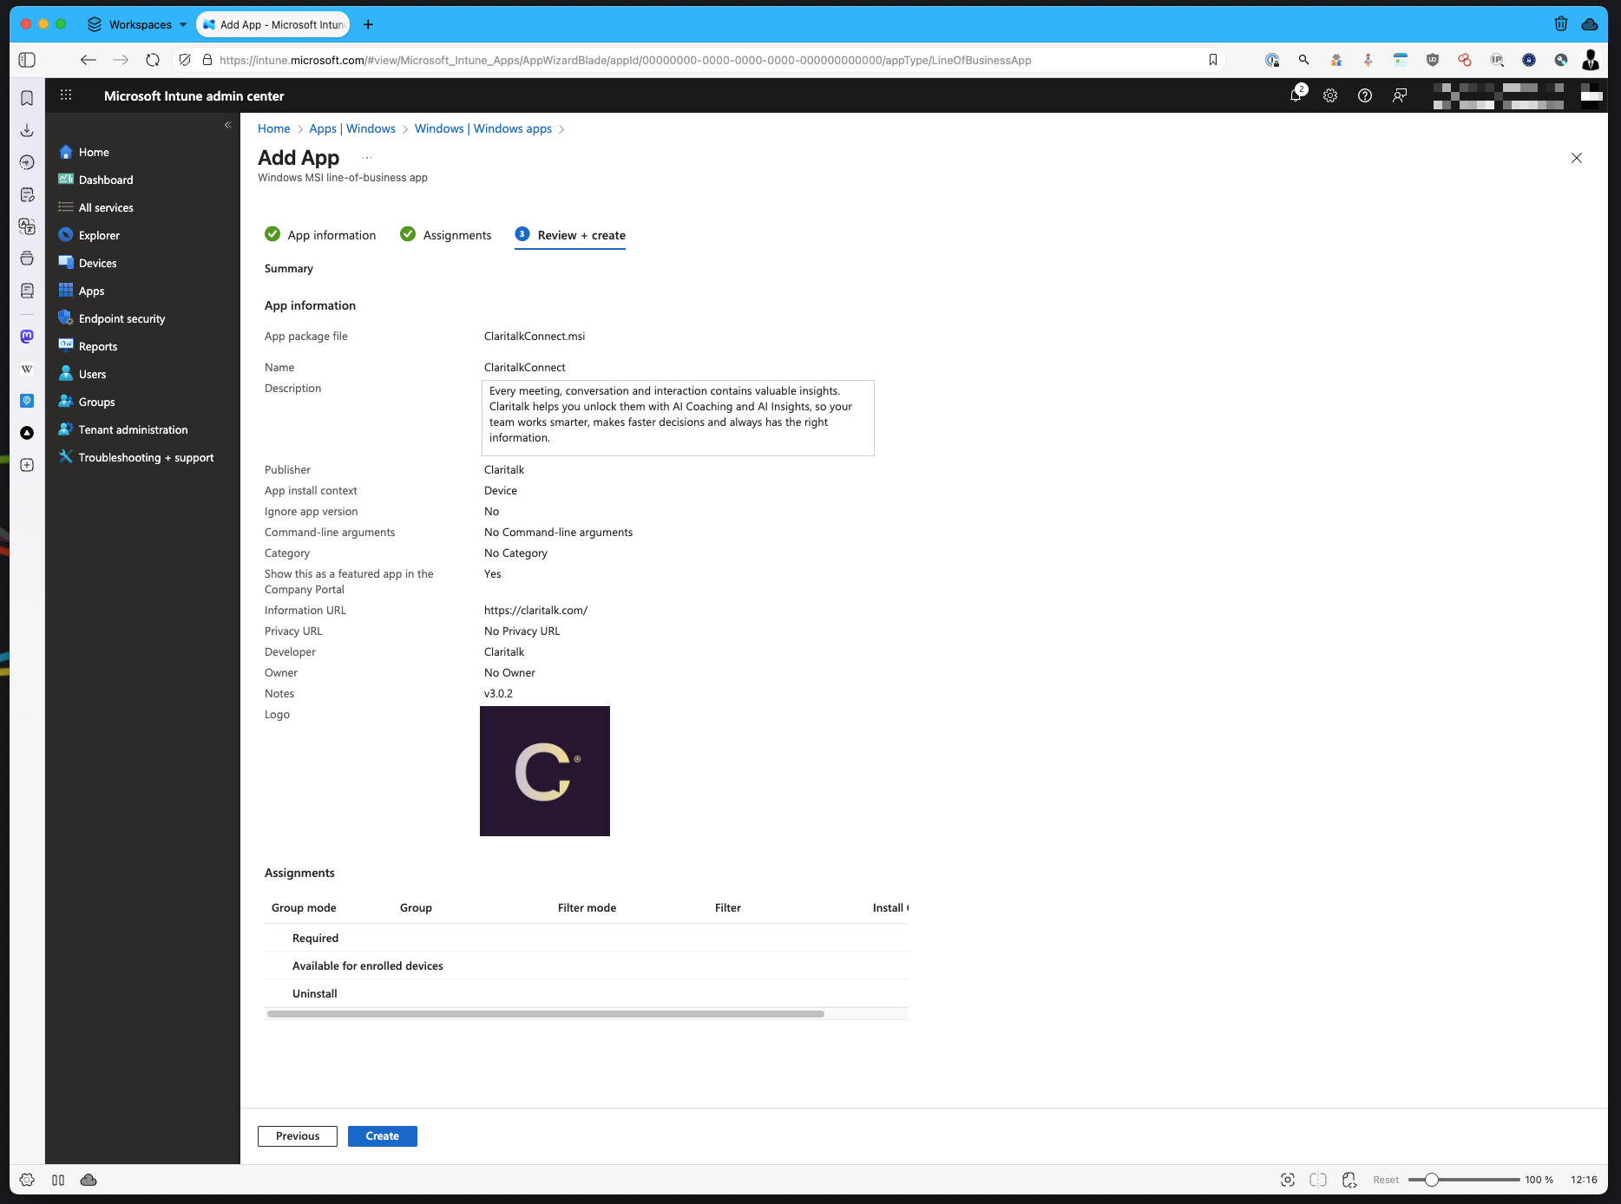Claritalk Connect appears for users

After installation
Each user enters his email address in Claritalk Connect once and receives a code by email.
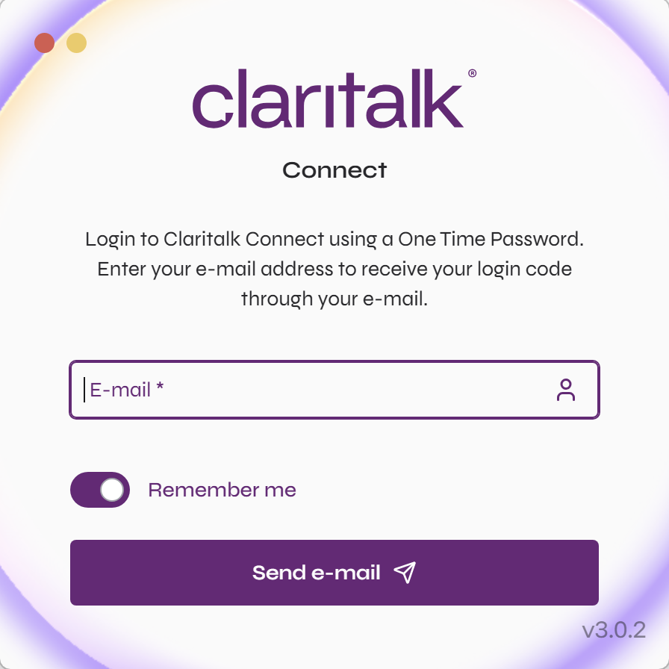
One-time login with email address and code
After entering the code, the user is authenticated and Claritalk Connect handles transcription when starting a meeting from app.claritalk.com or your internally connected systems.
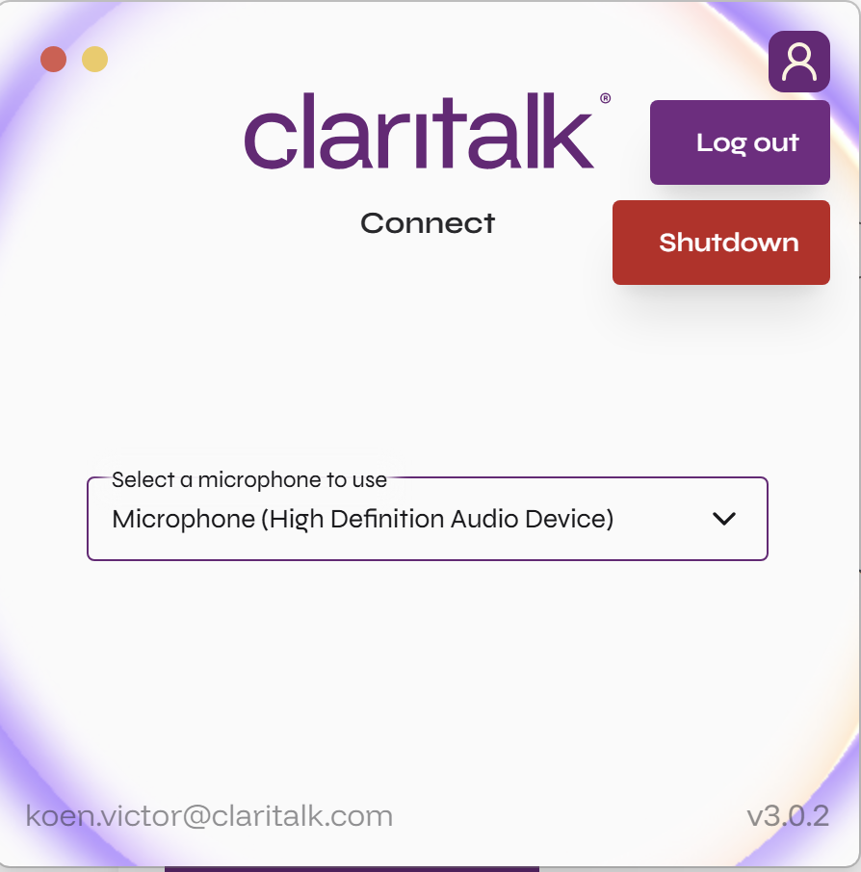
Claritalk Connect is ready to use
Ready
Happy Clari-talkin’! (Text thanks to a dedicated user.)
Found an error or need an addition? Let us know at support@claritalk.com and we'll help you out quickly.

